# Lab: Associative Arrays

Problems for in-class lab for the ["JS Fundamentals" course @ SoftUni](https://softuni.bg/trainings/2343/js-fundamentals-may-2019).   
Submit your solutions in the SoftUni judge system at: [Associative-Arrays -Lab](https://judge.softuni.bg/Contests/1231/)

## Phone Book

Write a function that stores information about a **person’s name** and his **phone number**. The input comes as an **array of strings**. Each string contains the name and the number. If you receive the same name **twice** just **replace** the number. At the end print the result **without sorting it**. Try using an **associative array.**

### Example

|  |  |
| --- | --- |
| **Input** | **Output** |
| ['Tim 0834212554',  'Peter 0877547887',  'Bill 0896543112',  'Tim 0876566344'] | Tim -> 0876566344  Peter -> 0877547887  Bill -> 0896543112 |

## Storage

Write a function that takes a certain number of **items** and their **quantity**. If the same item appears **more than once**, **add the new amount** to the **existing one**. At the end print all the items and their amount without sorting them. The input comes as **array of strings**. Try using a Map().

### Example

|  |  |
| --- | --- |
| **Input** | **Output** |
| ['tomatoes 10',  'coffee 5',  'olives 100',  'coffee 40'] | tomatoes -> 10  coffee -> 45  olives -> 100 |

### Hints

Create the solve() function and create a new Map():

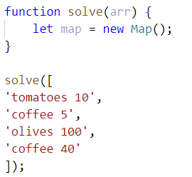

Loop through the array, split into tokens and create variables for each one:

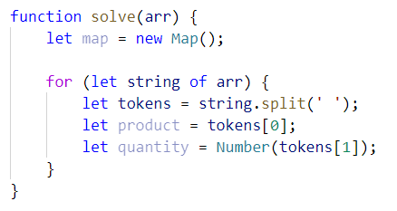

* This time for the quantity we need a number, because if we see the same product again, we must add the new quantity

Now let us make the checks for the keys in the map:

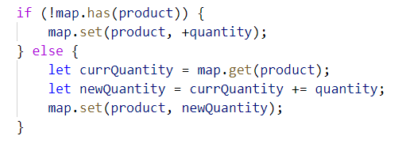

* First, we check if the map does ***NOT*** have the product we are currently at and **if so**, we **set it to the given quantity**
* Otherwise, we get the **existing quantity**, we **add the new quantity** and **set** the product’s quantity **to the new** one

Now we just have to print the result:

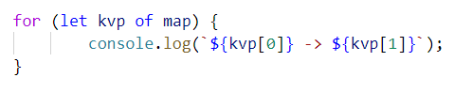

* Each key-value pair is and **array of 2 elements** (the **key** and the **value**), so we use **for-of** loop and print the key and the value

## School Grades

Write a function to store students with all of their grades. If a student appears more than once, add the new grades. At the end print the students sorted by average grade. The input comes as **array of strings**.

### Example

|  |  |
| --- | --- |
| **Input** | **Output** |
| ['Lilly 4 6 6 5',  'Tim 5 6',  'Tammy 2 4 3',  'Tim 6 6'] | Tammy: 2, 4, 3  Lilly: 4, 6, 6, 5  Tim: 5, 6, 6, 6 |

### Hints

Create the function, pass in the array, **split** each element into tokens, **extract** the **name** andthe **grades**:

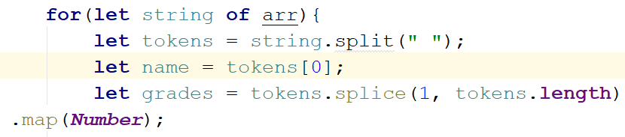

* The **grades** should be **numbers** (because we want to take the **average** later), so we map them toNumber

Now check if the map does ***NOT*** have the name and if so, **set it to an empty array** and **push all the grades**. Otherwise just **push the grades**:

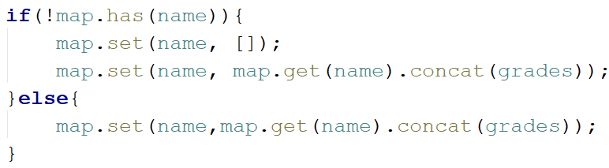

* If we **don’t have** the name, we need to **create it** and **concatenate [**concat()**]** the empty array and the new one
* Otherwise, we justconcat()them

Now we have to sort them by average grades:



Of course, there is no such function average, so we need to create it.

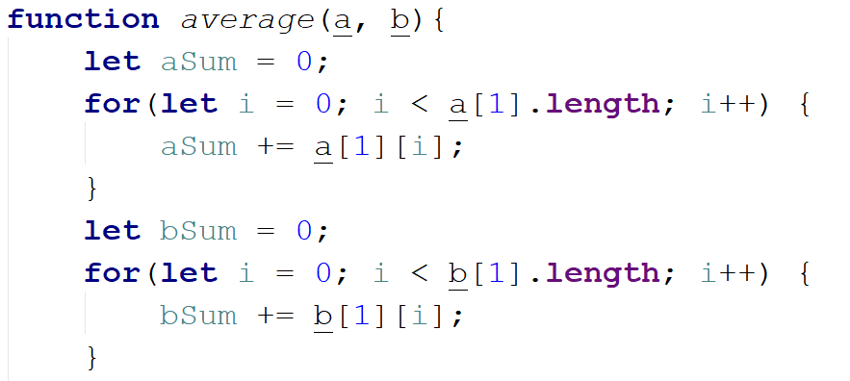

* a and b are two key-value pairs of our map. The grades are the values.
* For us to calculate average we need to take the sum and divide it by the length of each array

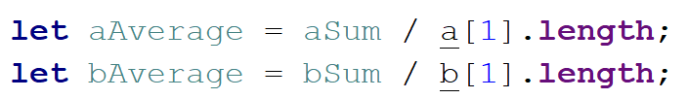

Finally, we return aAverage – bAverage:

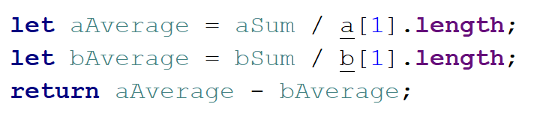

We sorted the map, now loop through the keys and values and print them in the format from the example.

## Word Occurrences

Write a function that **counts** the times each **word occurs** in a text. Print the words **sorted by count** in **descending** order. The input comes as an **array of strings**.

### Example

|  |  |
| --- | --- |
| **Input** | **Output** |
| ["Here", "is", "the", "first", "sentence", "Here", "is", "another", "sentence", "And", "finally", "the", "third", "sentence"] | sentence -> 3 times  Here -> 2 times  is -> 2 times  the -> 2 times  first -> 1 times  another -> 1 times  And -> 1 times  finally -> 1 times  third -> 1 times |

### Hint

* Create a map
* Loop through the elements of the array of words
* Update the map
* Sort the map by value in descending:



* Finally, print the result in format as the example above

## Neighborhoods

Write a function that receives **list of neighborhoods** and then some **people**, who are going to live in it. The **input** will come as **array of strings**. The **first element** will be the list of neighborhoods **separated** by **", "**. The rest of the element**s** will be a neighborhood followed by a **name** of a person in the format **"**{neighborhood} - {person}**"**. **Add** theperson to the neighborhood **only** if the neighborhood is inthe **list** of neighborhoods. At the end print the neighborhoods **sorted** by the count of inhabitants in descending order. Print them in the following format:

"{neighborhood}: {inhabitants count}

--{1st inhabitant}

--{2nd inhabitant}

…"

### Example

|  |  |
| --- | --- |
| **Input** | **Output** |
| ['Abbey Street, Herald Street, Bright Mews',  'Bright Mews - Garry',  'Bright Mews - Andrea',  'Invalid Street - Tommy',  'Abbey Street - Billy'] | Bright Mews: 2  --Garry  --Andrea  Abbey Street: 1  --Billy  Herald Street: 0 |

### Hints

* **Save** the first element of the array as the neighborhoods
* **Fill** the map with them and set their values as empty arrays
* **Loop** through the rest of the elements
* **Check** if the neighborhood is in the list/map and add the person
* **Sort** them by count of inhabitants
* **Print**

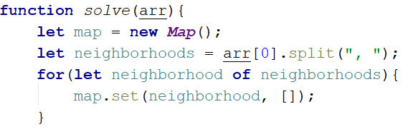

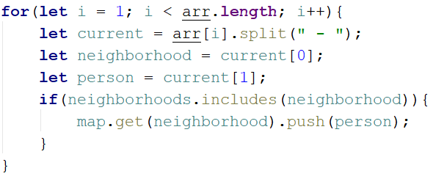

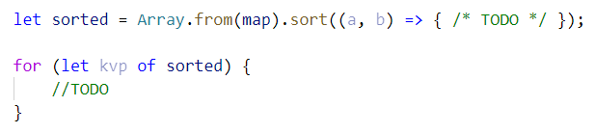

* ***NOTE:*** The count of the people is the length of the second element in both aand b**.** To sort in descending, just **subtract** the length of a inhabitance from the lengthof thebinhabitants.